BUDO JUNIOR SCHOOL
REMEDIAL WORK FOR TERM 1 2020 - SET TWO
ENGLISH FOR PRIMARY TWO

Name: _______________________________________________________________________________
Stream: ________________ Date: __________________________________________________

SECTION A
Fill in the blank spaces with a correct word.
1. She ate ______apple yesterday.
2. The rat is hiding ________________ the bed.
3. Her uniform is as ________________ as blood.
4. Mangoes _____________ sweet fruits.
5. We keep our school books in the ________________.
6. I use my ___________________ to hear.
7. A doctor is to hospital as a teacher is to________________ .
8. The father to my father is my ____________________.
9. This is my money. It is ___________________________.

Use the words in the brackets to complete the sentences.
10. They are ____________ to the sun. (point)
11. Mary likes _______________ with others. (share)
12. I have _______________ fingers., (10)
13. Tom ________________ his teeth everyday. (brush)
14. The children __________________ their clothes yesterday. (wash)
15. Jane is ____________________ a test now. (do)

In questions 16 – 17, use each of the given words to make a sentence.
16. cat - _______________________________________________________________
17. cut - _______________________________________________________________

In questions 18 – 20, match the nouns with the pronouns.
18. The girls it
19. Mary they
20. The pen she
In questions 21 – 22, give the opposite of the underlined words.
21. That is a small house. - __________________________________________________
22. Nairuba is a good girl. - _________________________________________________

In questions 23 – 24, write sentences correctly:
23. a bag Nakato has. –
______________________________________________________________________
24. going where you are?
______________________________________________________________________

In questions 25 – 27, give the plural form of the underlined words.
25. This is a pencil.
_______________ ______________________________________________________
26. My aunt has a baby.
______________________________________________________________________
27. The police officer arrested the thief.
______________________________________________________________________

Give one word for the underlined group of words.
28. My grandmother has a big garden where she grows matooke, cassava and sweet potatoes.
______________________________________________________________________
29. Tom has a sweater, a vest, a coat and a shirt.
______________________________________________________________________
In questions 30 – 32, complete the sentences correctly:
30. The cake is as sweet as _______________________
31. The tea is as cold as _________________________
32. A dog is to a puppy as a cow is to a __________________

Complete these riddles.
33. I teach pupils, I am a __________________________
34. I fly an aeroplane, I am a _____________________

In numbers 35 – 36, arrange the words in alphabetical order. (ABC)
35. doll , bag , axe , flag.
______________________________________________________________________
36. church , hospital , mosque , butcher’s.
______________________________________________________________________
Write correct sentences about the pictures below.
37.

_____________________________________________________________
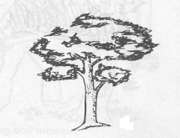
38. 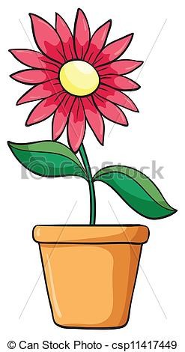_ _____________________________________________________________
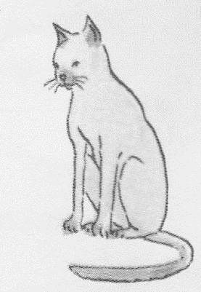
39.
___________________________________________________________
Subsection II.
Re-write as instructed in the brackets.
41. Moses is playing. Martin is playing. (Join using:…………and………)
______________________________________________________________________
42. What is the colour of your school uniform. (Answer correctly)
______________________________________________________________________
43. My uncle is poor. He has a good house. (Join using:…but…)
______________________________________________________________________
44. This is a child. (Begin: These…………………….)
______________________________________________________________________
45. We went to the dining room. We did not eat food.
(Join the sentences using:…..but….)
______________________________________________________________________
46. Mum is eating food. Dad is eating food. (Join using: ……..and ……)
______________________________________________________________________
47. That is my parent. (Begin: Those are …………)
______________________________________________________________________
48. Amber did not come to school. she was sick. (Join using: ….because….)
______________________________________________________________________
49. We are going to school now. (Rewrite using:….yesterday)
______________________________________________________________________
50. She has a pot. She has a knife. (Join using:……..and……)
______________________________________________________________________

SECTION B
51. Construct sentences using the table.

I  We  They  She  He | wash  dance  play  eats  goes | with a ball  clothes  an egg  to school | every time.  everyday.  every morning.  every day.  every Monday.

a) ______________________________________________________________________
b) ______________________________________________________________________
c) ______________________________________________________________________
d) ______________________________________________________________________
e) ______________________________________________________________________
52. Study the pictures below and answer the questions in full sentences.
MR. KABANDA’S FAMILY.
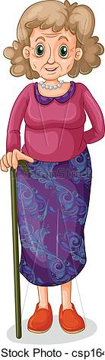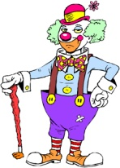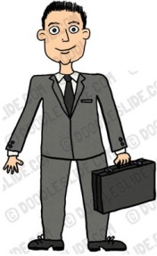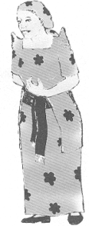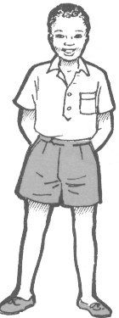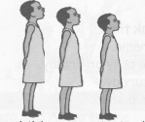
Paul

1. How many mothers are in Mr. Kabanda’s family?
______________________________________________________________________
2. Whose family are we looking at ?
______________________________________________________________________
3. How many sisters does Paul have?
______________________________________________________________________
4. Paul is Mr. Kabanda’s __________________
5. Are Paul’s grandparents sitting in the picture?
______________________________________________________________________

54. Arrange the following sentences to make a good story.
1. Lastly, she goes to her classroom.
2. Namuwonge wakes up very early.
3. She says her prayers.
4. Then she goes out to bathe.
5. She runs to the dining hall for breakfast.
6. After her prayers, she makes her bed.
____________________________________________________________________
____________________________________________________________________
____________________________________________________________________
____________________________________________________________________
____________________________________________________________________
____________________________________________________________________
____________________________________________________________________
53. Read the story carefully and answer the questions.

MY FRIEND
My friend’s name is Nankya. She is in primary two.
She goes to the market every Saturday.
She buys a pawpaw, a mango and an orange.
She eats potatoes, beans and pineapples on Sunday.
This food makes her healthy and strong.
Because she is healthy and strong, she studies well.
She reads her books and she writes well.
Her teacher likes her because she works hard in class.

Questions:
1. Write the title of the story.
______________________________________________________________________
2. In which class is Nankya?
______________________________________________________________________
3. What is the name of the friend in the story?
______________________________________________________________________
4. Where does Nankya go every Saturday?
______________________________________________________________________
5. Which food does she eat on Sunday?
______________________________________________________________________
6. What does Nankya buy from the Market?
______________________________________________________________________
7. Why do teachers like Nankya?
______________________________________________________________________
8. The food makes her _________________________ and ____________________.
9. Write a small word from Sunday. - _____________

